Experiment No. 8

**PANDAS**

Programming Assignment Screenshots

**PROBLEM 1:**

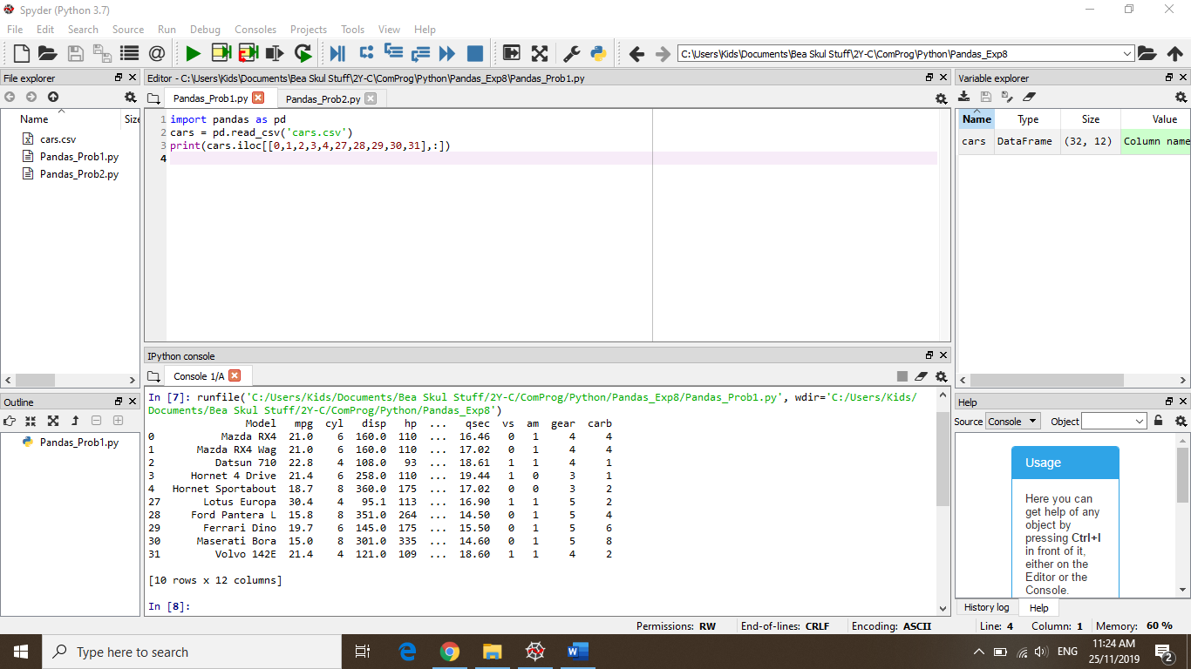

**PROBLEM 2:**

